EXAMINATION

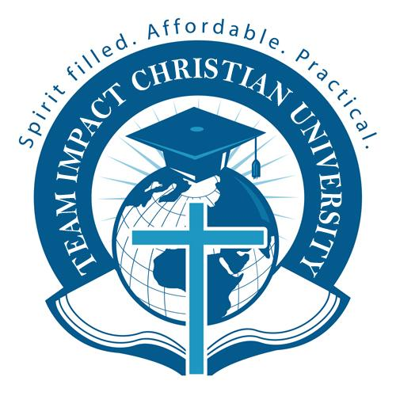
TEAM IMPACT CHRISTIAN UNIVERSITY

BP404 THE PROPHETIC ANOINTING

dean@powerhousecollege.com

Name
Student Number
Bible College (where applicable) | Powerhouse College

© 2010 Team Impact University
1. Take your time with this examination and express the answers in your own words. Do not cut and paste from the notes.

2. Take special note of the number of points awarded each question and supply equivalent information with supporting scriptures. E.g. If a question is worth ten points, give at least five points and five supporting scriptures. One point will be awarded for the answer in your words and one point for the supporting scripture.

3. Enjoy sharing what you have learned.

4. You may refer to your manual or any other resource when completing your examination.

5. Ensure that you include your name, student number and course code in the work that you submit for grading.

6. You may post your work to our offices or E-mail it to dean@powerhousecollege.com

7. You may find it easier to copy the whole question list into your favourite word processor.
Add the answers there and save as necessary. Email as an attachment.

GRADING SYSTEM

Grades are issued according to the following scales:

Grade | Percentage | Comments
A | 94 - 100% | Exceptional – Pass
B | 85 - 93% | Above Average – Pass
C | 73 - 84% | Average – Pass
D | 65 - 72% | Below Average – Pass
F | Below 65% | Unacceptable – Fail

START YOUR WORK NOW

Question 1
Who made the first prophecy in the New Covenant? (1)

Question 2
Write out the relevant passage of Scripture for this prophecy (2)

Question 3
Write out the passage of Scripture that urges us all to desire the prophetic gift (2)

Question 4
Complete this sentence: (1)
are called to stir up the prophetic Spirit in each believer.

Question 5
Complete this sentence: (1)
The prophetic anointing is powered

Question 6
Complete this sentence (1)
The prophetic anointing comes through the _____________, but it comes ____________.

Question 7
Write out this passage of Scripture: (2)
Revelation 19:10 ______________________________________________________________

Question 8
State whether true or false – “The gift of prophecy and the office of the prophet are the same thing.” (1)

Question 9
Complete this sentence – “The role of prophet in the Old Testament dealt with _____________” (1)

Question 10
Prove from Scripture, that all can prophecy (1)

Question 11
What is the main purpose of the prophetic anointing? (1)

Question 12
What 4 groups of people will be prophetic according to the Prophet Joel? (4)

Question 13
List the 3 sources of prophecy (3)

Question 14
What is a sixth sense? (1)

Question 15
Why did King Saul die? (Quote Scripture) (2)

Question 16
What is a psychic? (1)

Question 17
According to Scripture, why should we test prophecy? (1)

Question 18
Name 10 ways to test the spirits. (5)

Question 19
What 6 questions would you ask to ensure someone has the Biblical understanding of Jesus? (3)

Question 20
What are the 8 marks of a true prophet of God? (4)

Question 21
List 12 marks of a false prophet (6)

Question 22
List 8 reasons why Nostradamus was a false prophet in accordance with Scripture (4)

Question 23
When prophets speak, what does the audience do? (1)

Question 24
List 14 questions to ask when judging prophecy (7)

Question 25
List 12 ways you should respond to a prophecy over your life. (6)

Question 26
List 4 examples of a creative gift (4)

Question 27
Complete this sentence: “Spiritual gifts are given to ____________ and . They are God given abilities _______________.” (2)

Question 28
List the nine gifts of the Spirit. (3)

Question 29
State whether true of false – “The gifts are a permanent mantle given by the Spirit of God.” (1)

Question 30
What must you do with your gift? (1)

Question 31
What is the lowest level of prophecy? (1)

Question 32
Is the prophetic anointing and the office of a prophet the same thing? (1)

Question 33
Show from Scripture what is the main purpose of the gift of prophecy. (1)

Question 34
Complete this statement – “Operating in the revelatory gifts ” (1)

Question 35
Is this statement true or false – “Any Spirit filled believer can function prophetically in the knowing gifts.” (1)

Question 36
Is this statement true or false – “Many people claim to be prophets, but they are merely functioning in the knowing gifts.” (1)

Question 37
Who calls a person into the office of a prophet? (1)

Question 38
Can anyone choose to be a prophet? (1)

Question 39
Can anyone choose to operate in the prophetic anointing? (1)

Question 40
What is meant by “Foundational Ministries?” (1)

Question 41
What is Jeremiah’s definition of the prophetic – quote the Scripture (2)

Question 42
State whether the following if true or false: - “Every prophet will have the gift of prophecy but not every person who has the gift of prophecy is a prophet.” (1)

Question 43
Were Philips four daughters prophets? (1)

Question 44
Is this statement true or false – “The office of the prophet is a gift of the Holy Spirit and is available to all believers.” (1)

Question 45
Complete this sentence: “The prophet operates in the spiritual gifts as well, but because of the anointing and authority given by God, ____________________” (2)

Question 46
List 12 characteristics of a prophet (6)

Question 47
Describe the 12 characteristics of an Old Testament prophet (6) Question 48

Question 48
Describe 8 characteristics of New Covenant prophets (4)

Question 49
What is meant by the prophet’s reward? Include Scripture (2)

Question 50
List 10 ways that God speaks to us (5)

Question 51
List 12 characteristics of the devils’ voice (6)

Question 52
List 10 characteristics of God’s voice (5)

Question 53
List 10 things that can block out the voice of God is a person’s life (5)

Question 54
List 4 ways you can prepare effectively for the prophetic (2)

Question 55
Write an essay on Prophetic protocols (minimum of 500 words) (10)

TOTAL OF 142 POINTS = 100%

